**MAIN CLASS:**

import java.awt.event.ActionEvent;

import java.awt.event.ActionListener;

import java.sql.*;

import java.text.DateFormat;

import java.text.ParseException;

import java.text.SimpleDateFormat;

import java.util.ArrayList;

import java.util.Date;

import java.util.Locale;

import java.util.concurrent.TimeUnit;

 import javax.swing.*;

import net.proteanit.sql.DbUtils;

 public class main {

      public static class ex{

        public static int days=0;

            }

  public static void main(String[] args) {

        login();

        //create();

    }

**LOGIN:**

public static void login() {

    JFrame f=new JFrame("Login");//creating instance of JFrame

    JLabel l1,l2;

    l1=new JLabel("Username");  //Create label Username

    l1.setBounds(30,15, 100,30); //x axis, y axis, width, height

    l2=new JLabel("Password");  //Create label Password

    l2.setBounds(30,50, 100,30);

      JTextField F_user = new JTextField(); //Create text field for username

     F_user.setBounds(110, 15, 200, 30);

       JPasswordField F_pass=new JPasswordField(); //Create text field for password

     F_pass.setBounds(110, 50, 200, 30);

    JButton login_but=new JButton("Login");//creating instance of JButton for Login Button

    login_but.setBounds(130,90,80,25);//Dimensions for button

    login_but.addActionListener(new ActionListener() {  //Perform action

        public void actionPerformed(ActionEvent e){

        String username = F_user.getText(); //Store username entered by the user in the variable "username"

        String password = F_pass.getText(); //Store password entered by the user in the variable "password"

        if(username.equals("")) //If username is null

        {

            JOptionPane.showMessageDialog(null,"Please enter username"); //Display dialog box with the message

        }

        else if(password.equals("")) //If password is null

        {

            JOptionPane.showMessageDialog(null,"Please enter password"); //Display dialog box with the message

        }

        else { //If both the fields are present then to login the user, check whether the user exists already

            //System.out.println("Login connect");

            Connection connection=connect();  //Connect to the database

            try

            {

            Statement stmt = connection.createStatement();

              stmt.executeUpdate("USE LIBRARY"); //Use the database with the name "Library"

              String st = ("SELECT * FROM USERS WHERE USERNAME='"+username+"' AND PASSWORD='"+password+"'"); //Retreive username and passwords from users

              ResultSet rs = stmt.executeQuery(st); //Execute query

              if(rs.next()==false) { //Move pointer below

                  System.out.print("No user");

                  JOptionPane.showMessageDialog(null,"Wrong Username/Password!"); //Display Message

              }

              else {

else {

                  f.dispose();

                rs.beforeFirst();  //Move the pointer above

                while(rs.next())

                {

                  String admin = rs.getString("ADMIN"); //user is admin

                  //System.out.println(admin);

                  String UID = rs.getString("UID"); //Get user ID of the user

                  if(admin.equals("1")) { //If boolean value 1

                      admin_menu(); //redirect to admin menu

                  }

                  else{

                      user_menu(UID); //redirect to user menu for that user ID

                  }

              }

              }

            }

            catch (Exception ex) {

                 ex.printStackTrace();

        }

        }

    }

    });

    f.add(F_pass); //add password

    f.add(login_but);//adding button in JFrame

    f.add(F_user);  //add user

    f.add(l1);  // add label1 i.e. for username

    f.add(l2); // add label2 i.e. for password

    f.setSize(400,180);//400 width and 500 height

    f.setLayout(null);//using no layout managers

    f.setVisible(true);//making the frame visible

    f.setLocationRelativeTo(null);

}

**CONNECT:**

public static Connection connect()

{

try {

        Class.forName("com.mysql.cj.jdbc.Driver");

        //System.out.println("Loaded driver");

        Connection con = DriverManager.getConnection("jdbc:mysql://localhost/mysql?user=root&password=edureka");

        //System.out.println("Connected to MySQL");

        return con;

 }

 catch (Exception ex) {

        ex.printStackTrace();

 }

return null;

}

**CREATE:**

public static void create() {

    try {

    Connection connection=connect();

    ResultSet resultSet = connection.getMetaData().getCatalogs();

    //iterate each catalog in the ResultSet

        while (resultSet.next()) {

          // Get the database name, which is at position 1

          String databaseName = resultSet.getString(1);

          if(databaseName.equals("library")) {

              //System.out.print("yes");

              Statement stmt = connection.createStatement();

              //Drop database if it pre-exists to reset the complete database

              String sql = "DROP DATABASE library";

              stmt.executeUpdate(sql);

          }

        }

          Statement stmt = connection.createStatement();

          String sql = "CREATE DATABASE LIBRARY"; //Create Database

          stmt.executeUpdate(sql);

          stmt.executeUpdate("USE LIBRARY"); //Use Database

          //Create Users Table

          String sql1 = "CREATE TABLE USERS(UID INT NOT NULL AUTO_INCREMENT PRIMARY KEY, USERNAME VARCHAR(30), PASSWORD VARCHAR(30), ADMIN BOOLEAN)";

          stmt.executeUpdate(sql1);

          //Insert into users table

          stmt.executeUpdate("INSERT INTO USERS(USERNAME, PASSWORD, ADMIN) VALUES('admin','admin',TRUE)");

          //Create Books table

          stmt.executeUpdate("CREATE TABLE BOOKS(BID INT NOT NULL AUTO_INCREMENT PRIMARY KEY, BNAME VARCHAR(50), GENRE VARCHAR(20), PRICE INT)");

          //Create Issued Table

          stmt.executeUpdate("CREATE TABLE ISSUED(IID INT NOT NULL AUTO_INCREMENT PRIMARY KEY, UID INT, BID INT, ISSUED_DATE VARCHAR(20), RETURN_DATE VARCHAR(20), PERIOD INT, FINE INT)");

          //Insert into books table

          stmt.executeUpdate("INSERT INTO BOOKS(BNAME, GENRE, PRICE) VALUES ('War and Peace', 'Mystery', 200),  ('The Guest Book', 'Fiction', 300), ('The Perfect Murder','Mystery', 150), ('Accidental Presidents', 'Biography', 250), ('The Wicked King','Fiction', 350)");

    resultSet.close();

    }

     catch (Exception ex) {

         ex.printStackTrace();

}

}

**USER MENU:**

public static void user_menu(String UID) {

    JFrame f=new JFrame("User Functions"); //Give dialog box name as User functions

    //f.setDefaultCloseOperation(JFrame.EXIT_ON_CLOSE); //Exit user menu on closing the dialog box

    JButton view_but=new JButton("View Books");//creating instance of JButton

    view_but.setBounds(20,20,120,25);//x axis, y axis, width, height

    view_but.addActionListener(new ActionListener() {

        public void actionPerformed(ActionEvent e){

            JFrame f = new JFrame("Books Available"); //View books stored in database

            //f.setDefaultCloseOperation(JFrame.EXIT_ON_CLOSE);

            Connection connection = connect();

            String sql="select * from BOOKS"; //Retreive data from database

            try {

                Statement stmt = connection.createStatement(); //connect to database

                 stmt.executeUpdate("USE LIBRARY"); // use librabry

                stmt=connection.createStatement();

                ResultSet rs=stmt.executeQuery(sql);

                JTable book_list= new JTable(); //show data in table format

                book_list.setModel(DbUtils.resultSetToTableModel(rs));

                JScrollPane scrollPane = new JScrollPane(book_list); //enable scroll bar

                f.add(scrollPane); //add scroll bar

                f.setSize(800, 400); //set dimensions of view books frame

                f.setVisible(true);

                f.setLocationRelativeTo(null);

            } catch (SQLException e1) {

                // TODO Auto-generated catch block

                 JOptionPane.showMessageDialog(null, e1);

            }

    }

    }

    );

    JButton my_book=new JButton("My Books");//creating instance of JButton

    my_book.setBounds(150,20,120,25);//x axis, y axis, width, height

    my_book.addActionListener(new ActionListener() { //Perform action

        public void actionPerformed(ActionEvent e){

            JFrame f = new JFrame("My Books"); //View books issued by user

            //f.setDefaultCloseOperation(JFrame.EXIT_ON_CLOSE);

            int UID_int = Integer.parseInt(UID); //Pass user ID

            //.iid,issued.uid,issued.bid,issued.issued_date,issued.return_date,issued,

            Connection connection = connect(); //connect to database

            //retrieve data

            String sql="select distinct issued.*,books.bname,books.genre,books.price from issued,books " + "where ((issued.uid=" + UID_int + ") and (books.bid in (select bid from issued where issued.uid="+UID_int+"))) group by iid";

            String sql1 = "select bid from issued where uid="+UID_int;

            try {

                Statement stmt = connection.createStatement();

                //use database

                 stmt.executeUpdate("USE LIBRARY");

                stmt=connection.createStatement();

                //store in array

                ArrayList books_list = new ArrayList();

                ResultSet rs=stmt.executeQuery(sql);

                JTable book_list= new JTable(); //store data in table format

                book_list.setModel(DbUtils.resultSetToTableModel(rs));

                //enable scroll bar

                JScrollPane scrollPane = new JScrollPane(book_list);

                f.add(scrollPane); //add scroll bar

                f.setSize(800, 400); //set dimensions of my books frame

                f.setVisible(true);

                f.setLocationRelativeTo(null);

            } catch (SQLException e1) {

                // TODO Auto-generated catch block

                 JOptionPane.showMessageDialog(null, e1);

            }

    }

    }

    );

    f.add(my_book); //add my books

    f.add(view_but); // add view books

    f.setSize(300,100);//400 width and 500 height

    f.setLayout(null);//using no layout managers

    f.setVisible(true);//making the frame visible

    f.setLocationRelativeTo(null);

    }

**ADMIN MENU:**

public static void admin_menu() {

    JFrame f=new JFrame("Admin Functions"); //Give dialog box name as admin functions

    //f.setDefaultCloseOperation(JFrame.EXIT_ON_CLOSE); //

    JButton create_but=new JButton("Create/Reset");//creating instance of JButton to create or reset database

    create_but.setBounds(450,60,120,25);//x axis, y axis, width, height

    create_but.addActionListener(new ActionListener() { //Perform action

        public void actionPerformed(ActionEvent e){

            create(); //Call create function

            JOptionPane.showMessageDialog(null,"Database Created/Reset!"); //Open a dialog box and display the message

        }

    });

    JButton view_but=new JButton("View Books");//creating instance of JButton to view books

    view_but.setBounds(20,20,120,25);//x axis, y axis, width, height

    view_but.addActionListener(new ActionListener() {

        public void actionPerformed(ActionEvent e){

            JFrame f = new JFrame("Books Available");

            //f.setDefaultCloseOperation(JFrame.EXIT_ON_CLOSE);

            Connection connection = connect(); //connect to database

            String sql="select * from BOOKS"; //select all books

            try {

                Statement stmt = connection.createStatement();

                 stmt.executeUpdate("USE LIBRARY"); //use database

                stmt=connection.createStatement();

                ResultSet rs=stmt.executeQuery(sql);

                JTable book_list= new JTable(); //view data in table format

                book_list.setModel(DbUtils.resultSetToTableModel(rs));

                //mention scroll bar

                JScrollPane scrollPane = new JScrollPane(book_list);

                f.add(scrollPane); //add scrollpane

                f.setSize(800, 400); //set size for frame

                f.setVisible(true);

                f.setLocationRelativeTo(null);

            } catch (SQLException e1) {

                // TODO Auto-generated catch block

                 JOptionPane.showMessageDialog(null, e1);

            }

    }

    }

    );

    JButton users_but=new JButton("View Users");//creating instance of JButton to view users

    users_but.setBounds(150,20,120,25);//x axis, y axis, width, height

    users_but.addActionListener(new ActionListener() { //Perform action on click button

        public void actionPerformed(ActionEvent e){

                JFrame f = new JFrame("Users List");

                //f.setDefaultCloseOperation(JFrame.EXIT_ON_CLOSE);

                Connection connection = connect();

                String sql="select * from users"; //retrieve all users

                try {

                    Statement stmt = connection.createStatement();

                     stmt.executeUpdate("USE LIBRARY"); //use database

                    stmt=connection.createStatement();

                    ResultSet rs=stmt.executeQuery(sql);

                    JTable book_list= new JTable();

                    book_list.setModel(DbUtils.resultSetToTableModel(rs));

                    //mention scroll bar

                    JScrollPane scrollPane = new JScrollPane(book_list);

                    f.add(scrollPane); //add scrollpane

                    f.setSize(800, 400); //set size for frame

                    f.setVisible(true);

                    f.setLocationRelativeTo(null);

                } catch (SQLException e1) {

                    // TODO Auto-generated catch block

                     JOptionPane.showMessageDialog(null, e1);

                }

    }

        }

    );

    JButton issued_but=new JButton("View Issued Books");//creating instance of JButton to view the issued books

    issued_but.setBounds(280,20,160,25);//x axis, y axis, width, height

    issued_but.addActionListener(new ActionListener() {

        public void actionPerformed(ActionEvent e){

                JFrame f = new JFrame("Users List");

                //f.setDefaultCloseOperation(JFrame.EXIT_ON_CLOSE);

                Connection connection = connect();

                String sql="select * from issued";

                try {

                    Statement stmt = connection.createStatement();

                     stmt.executeUpdate("USE LIBRARY");

                    stmt=connection.createStatement();

                    ResultSet rs=stmt.executeQuery(sql);

                    JTable book_list= new JTable();

                    book_list.setModel(DbUtils.resultSetToTableModel(rs));

                    JScrollPane scrollPane = new JScrollPane(book_list);

                    f.add(scrollPane);

                    f.setSize(800, 400);

                    f.setVisible(true);

                    f.setLocationRelativeTo(null);

                } catch (SQLException e1) {

                    // TODO Auto-generated catch block

                     JOptionPane.showMessageDialog(null, e1);

                }

    }

        }

    );

    JButton add_user=new JButton("Add User"); //creating instance of JButton to add users

    add_user.setBounds(20,60,120,25); //set dimensions for button

    add_user.addActionListener(new ActionListener() {

        public void actionPerformed(ActionEvent e){

                JFrame g = new JFrame("Enter User Details"); //Frame to enter user details

                //g.setDefaultCloseOperation(JFrame.EXIT_ON_CLOSE);

                //Create label

                JLabel l1,l2;

                l1=new JLabel("Username");  //label 1 for username

                l1.setBounds(30,15, 100,30);

                l2=new JLabel("Password");  //label 2 for password

                l2.setBounds(30,50, 100,30);

                //set text field for username

                JTextField F_user = new JTextField();

                F_user.setBounds(110, 15, 200, 30);

                //set text field for password

                JPasswordField F_pass=new JPasswordField();

                F_pass.setBounds(110, 50, 200, 30);

                //set radio button for admin

                JRadioButton a1 = new JRadioButton("Admin");

                a1.setBounds(55, 80, 200,30);

                //set radio button for user

                JRadioButton a2 = new JRadioButton("User");

                a2.setBounds(130, 80, 200,30);

                //add radio buttons

                ButtonGroup bg=new ButtonGroup();

                bg.add(a1);bg.add(a2);

                JButton create_but=new JButton("Create");//creating instance of JButton for Create

                create_but.setBounds(130,130,80,25);//x axis, y axis, width, height

                create_but.addActionListener(new ActionListener() {

                    public void actionPerformed(ActionEvent e){

                    String username = F_user.getText();

                    String password = F_pass.getText();

                    Boolean admin = false;

                    if(a1.isSelected()) {

                        admin=true;

                    }

                    Connection connection = connect();

                    try {

                    Statement stmt = connection.createStatement();

                     stmt.executeUpdate("USE LIBRARY");

                     stmt.executeUpdate("INSERT INTO USERS(USERNAME,PASSWORD,ADMIN) VALUES ('"+username+"','"+password+"',"+admin+")");

                     JOptionPane.showMessageDialog(null,"User added!");

                     g.dispose();

                    }

                    catch (SQLException e1) {

                        // TODO Auto-generated catch block

                         JOptionPane.showMessageDialog(null, e1);

                    }

                    }

                });

                    g.add(create_but);

                    g.add(a2);

                    g.add(a1);

                    g.add(l1);

                    g.add(l2);

                    g.add(F_user);

                    g.add(F_pass);

                    g.setSize(350,200);//400 width and 500 height

                    g.setLayout(null);//using no layout managers

                    g.setVisible(true);//making the frame visible

                    g.setLocationRelativeTo(null);

    }

    });

    JButton add_book=new JButton("Add Book"); //creating instance of JButton for adding books

    add_book.setBounds(150,60,120,25);

    add_book.addActionListener(new ActionListener() {

        public void actionPerformed(ActionEvent e){

                //set frame wot enter book details

                JFrame g = new JFrame("Enter Book Details");

                //g.setDefaultCloseOperation(JFrame.EXIT_ON_CLOSE);

                // set labels

                JLabel l1,l2,l3;

                l1=new JLabel("Book Name");  //lebel 1 for book name

                l1.setBounds(30,15, 100,30);

                l2=new JLabel("Genre");  //label 2 for genre

                l2.setBounds(30,53, 100,30);

                l3=new JLabel("Price");  //label 2 for price

                l3.setBounds(30,90, 100,30);

                //set text field for book name

                JTextField F_bname = new JTextField();

                F_bname.setBounds(110, 15, 200, 30);

                //set text field for genre

                JTextField F_genre=new JTextField();

                F_genre.setBounds(110, 53, 200, 30);

                //set text field for price

                JTextField F_price=new JTextField();

                F_price.setBounds(110, 90, 200, 30);

                JButton create_but=new JButton("Submit");//creating instance of JButton to submit details

                create_but.setBounds(130,130,80,25);//x axis, y axis, width, height

                create_but.addActionListener(new ActionListener() {

                    public void actionPerformed(ActionEvent e){

                    // assign the book name, genre, price

                    String bname = F_bname.getText();

                    String genre = F_genre.getText();

                    String price = F_price.getText();

                    //convert price of integer to int

                    int price_int = Integer.parseInt(price);

                    Connection connection = connect();

                    try {

                    Statement stmt = connection.createStatement();

                     stmt.executeUpdate("USE LIBRARY");

                     stmt.executeUpdate("INSERT INTO BOOKS(BNAME,GENRE,PRICE) VALUES ('"+bname+"','"+genre+"',"+price_int+")");

                     JOptionPane.showMessageDialog(null,"Book added!");

                     g.dispose();

                    }

                    catch (SQLException e1) {

                        // TODO Auto-generated catch block

                         JOptionPane.showMessageDialog(null, e1);

                    }

                    }

                });

                    g.add(l3);

                    g.add(create_but);

                    g.add(l1);

                    g.add(l2);

                    g.add(F_bname);

                    g.add(F_genre);

                    g.add(F_price);

                    g.setSize(350,200);//400 width and 500 height

                    g.setLayout(null);//using no layout managers

                    g.setVisible(true);//making the frame visible

                    g.setLocationRelativeTo(null);

    }

    });

    JButton issue_book=new JButton("Issue Book"); //creating instance of JButton to issue books

    issue_book.setBounds(450,20,120,25);

    issue_book.addActionListener(new ActionListener() {

        public void actionPerformed(ActionEvent e){

                //enter details

                JFrame g = new JFrame("Enter Details");

                //g.setDefaultCloseOperation(JFrame.EXIT_ON_CLOSE);

                //create labels

                JLabel l1,l2,l3,l4;

                l1=new JLabel("Book ID(BID)");  // Label 1 for Book ID

                l1.setBounds(30,15, 100,30);

                l2=new JLabel("User ID(UID)");  //Label 2 for user ID

                l2.setBounds(30,53, 100,30);

                l3=new JLabel("Period(days)");  //Label 3 for period

                l3.setBounds(30,90, 100,30);

                l4=new JLabel("Issued Date(DD-MM-YYYY)");  //Label 4 for issue date

                l4.setBounds(30,127, 150,30);

                JTextField F_bid = new JTextField();

                F_bid.setBounds(110, 15, 200, 30);

                JTextField F_uid=new JTextField();

                F_uid.setBounds(110, 53, 200, 30);

                JTextField F_period=new JTextField();

                F_period.setBounds(110, 90, 200, 30);

                JTextField F_issue=new JTextField();

                F_issue.setBounds(180, 130, 130, 30);

                JButton create_but=new JButton("Submit");//creating instance of JButton

                create_but.setBounds(130,170,80,25);//x axis, y axis, width, height

                create_but.addActionListener(new ActionListener() {

                    public void actionPerformed(ActionEvent e){

                    String uid = F_uid.getText();

                    String bid = F_bid.getText();

                    String period = F_period.getText();

                    String issued_date = F_issue.getText();

                    int period_int = Integer.parseInt(period);

                    Connection connection = connect();

                    try {

                    Statement stmt = connection.createStatement();

                     stmt.executeUpdate("USE LIBRARY");

                     stmt.executeUpdate("INSERT INTO ISSUED(UID,BID,ISSUED_DATE,PERIOD) VALUES ('"+uid+"','"+bid+"','"+issued_date+"',"+period_int+")");

                     JOptionPane.showMessageDialog(null,"Book Issued!");

                     g.dispose();

                    }

                    catch (SQLException e1) {

                        // TODO Auto-generated catch block

                         JOptionPane.showMessageDialog(null, e1);

                    }

                    }

                });

                    g.add(l3);

                    g.add(l4);

                    g.add(create_but);

                    g.add(l1);

                    g.add(l2);

                    g.add(F_uid);

                    g.add(F_bid);

                    g.add(F_period);

                    g.add(F_issue);

                    g.setSize(350,250);//400 width and 500 height

                    g.setLayout(null);//using no layout managers

                    g.setVisible(true);//making the frame visible

                    g.setLocationRelativeTo(null);

    }

    });

    JButton return_book=new JButton("Return Book"); //creating instance of JButton to return books

    return_book.setBounds(280,60,160,25);

    return_book.addActionListener(new ActionListener() {

        public void actionPerformed(ActionEvent e){

                JFrame g = new JFrame("Enter Details");

                //g.setDefaultCloseOperation(JFrame.EXIT_ON_CLOSE);

                //set labels

                JLabel l1,l2,l3,l4;

                l1=new JLabel("Issue ID(IID)");  //Label 1 for Issue ID

                l1.setBounds(30,15, 100,30);

                l4=new JLabel("Return Date(DD-MM-YYYY)");

                l4.setBounds(30,50, 150,30);

                JTextField F_iid = new JTextField();

                F_iid.setBounds(110, 15, 200, 30);

                JTextField F_return=new JTextField();

                F_return.setBounds(180, 50, 130, 30);

                JButton create_but=new JButton("Return");//creating instance of JButton to mention return date and calculcate fine

                create_but.setBounds(130,170,80,25);//x axis, y axis, width, height

                create_but.addActionListener(new ActionListener() {

                    public void actionPerformed(ActionEvent e){

                    String iid = F_iid.getText();

                    String return_date = F_return.getText();

                    Connection connection = connect();

                    try {

                    Statement stmt = connection.createStatement();

                     stmt.executeUpdate("USE LIBRARY");

                     //Intialize date1 with NULL value

                     String date1=null;

                     String date2=return_date; //Intialize date2 with return date

                     //select issue date

                     ResultSet rs = stmt.executeQuery("SELECT ISSUED_DATE FROM ISSUED WHERE IID="+iid);

                     while (rs.next()) {

                         date1 = rs.getString(1);

                       }

                     try {

                            Date date_1=new SimpleDateFormat("dd-MM-yyyy").parse(date1);

                            Date date_2=new SimpleDateFormat("dd-MM-yyyy").parse(date2);

                            //subtract the dates and store in diff

                            long diff = date_2.getTime() - date_1.getTime();

                            //Convert diff from milliseconds to days

                            ex.days=(int)(TimeUnit.DAYS.convert(diff, TimeUnit.MILLISECONDS));

                        } catch (ParseException e1) {

                            // TODO Auto-generated catch block

                            e1.printStackTrace();

                        }

                     //update return date

                     stmt.executeUpdate("UPDATE ISSUED SET RETURN_DATE='"+return_date+"' WHERE IID="+iid);

                     g.dispose();

                     Connection connection1 = connect();

                     Statement stmt1 = connection1.createStatement();

                     stmt1.executeUpdate("USE LIBRARY");

                    ResultSet rs1 = stmt1.executeQuery("SELECT PERIOD FROM ISSUED WHERE IID="+iid); //set period

                    String diff=null;

                    while (rs1.next()) {

                         diff = rs1.getString(1);

                       }

                    int diff_int = Integer.parseInt(diff);

                    if(ex.days&amp;amp;amp;amp;amp;amp;amp;amp;amp;amp;gt;diff_int) { //If number of days are more than the period then calculcate fine

                        //System.out.println(ex.days);

                        int fine = (ex.days-diff_int)*10; //fine for every day after the period is Rs 10.

                        //update fine in the system

                        stmt1.executeUpdate("UPDATE ISSUED SET FINE="+fine+" WHERE IID="+iid);

                        String fine_str = ("Fine: Rs. "+fine);

                        JOptionPane.showMessageDialog(null,fine_str);

                    }

                     JOptionPane.showMessageDialog(null,"Book Returned!");

                    }

                    catch (SQLException e1) {

                        // TODO Auto-generated catch block

                         JOptionPane.showMessageDialog(null, e1);

                    }

                    }

                });

                    g.add(l4);

                    g.add(create_but);

                    g.add(l1);

                    g.add(F_iid);

                    g.add(F_return);

                    g.setSize(350,250);//400 width and 500 height

                    g.setLayout(null);//using no layout managers

                    g.setVisible(true);//making the frame visible

                    g.setLocationRelativeTo(null);

    }

    });

    f.add(create_but);

    f.add(return_book);

    f.add(issue_book);

    f.add(add_book);

    f.add(issued_but);

    f.add(users_but);

    f.add(view_but);

    f.add(add_user);

    f.setSize(600,200);//400 width and 500 height

    f.setLayout(null);//using no layout managers

    f.setVisible(true);//making the frame visible

    f.setLocationRelativeTo(null);

    }

}

**OUTPUT:**

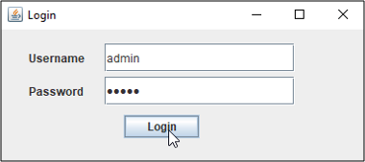

Once you click on the **Login button**, you will see the below dialog box opening.

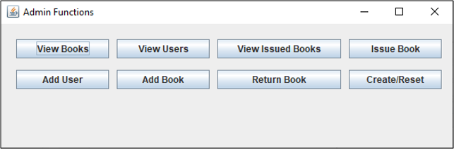

**View Books**

Once, you click on View Books button, you will see the below frame displaying all the books present in the database, with their details.

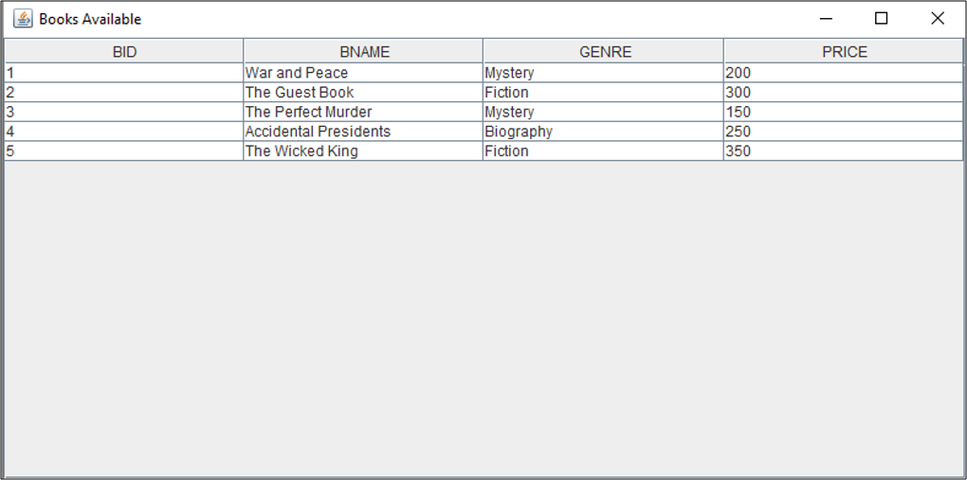

**View Users**

The View Users button is used to view the current users on the system. Since we just have only one user present i.e. the admin, it will show you output as below:

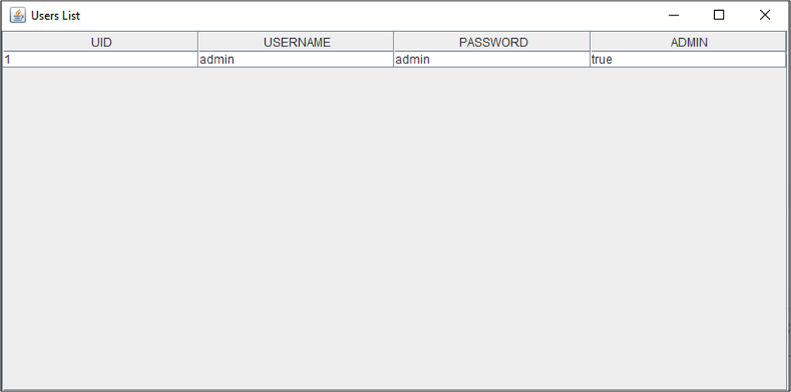

#### Create/Reset

This functionality is used to create or reset a database. So, once you click on the button Create/Rest, you will see the below output:

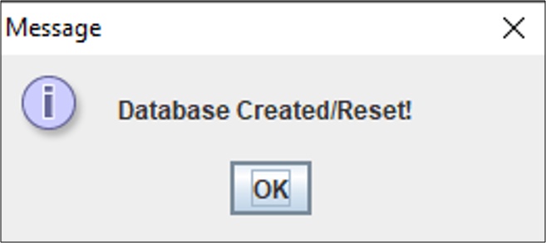

**Add User**

To add a user, click on the option “**Add User**” and mention details such as **username, password and choose the radio button user or admin**. By default, it will be the user. Then, click on **Create**.

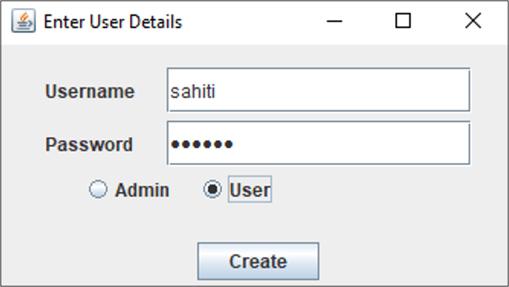

Once the user is created, you will see an output as below:

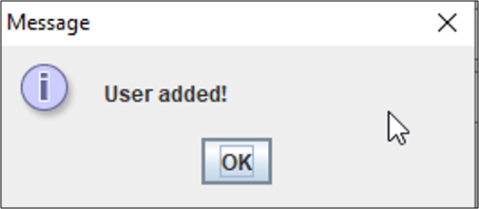

Now, again if you click on **View Users button**, you will see the below output:

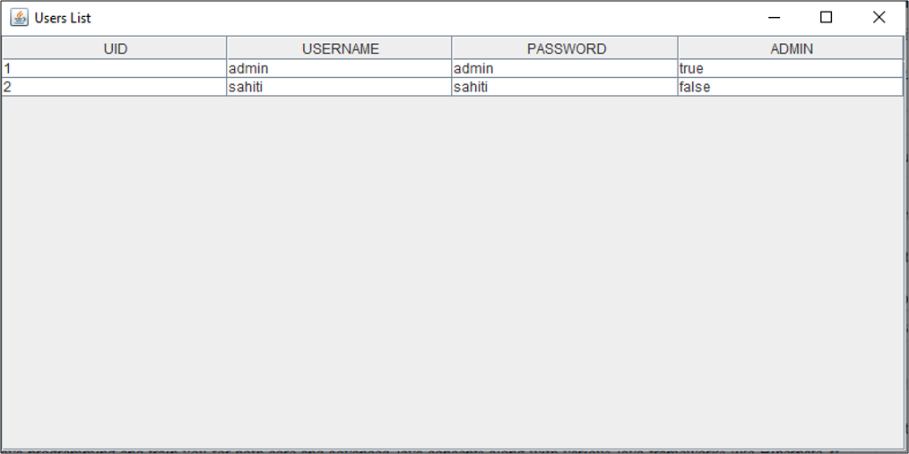

**Issue Book**

Suppose, if you are the user, once you click on the**Issue Book button**, you have to mention the **Book ID, User ID, Period(Number of days for issuing the book)**, and the **Issue Date** as follows:

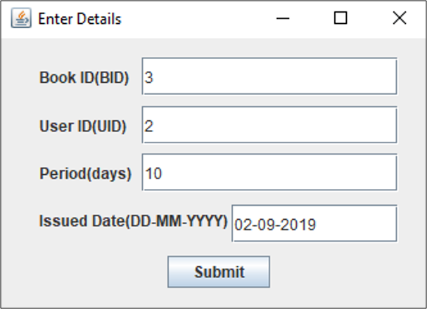

Then click on **Submit**. Once, you click on **Submit**, you will see the below dialog box:

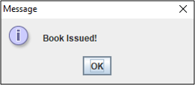

**View Issued Books**

Once you click on this button, you will see the following output:

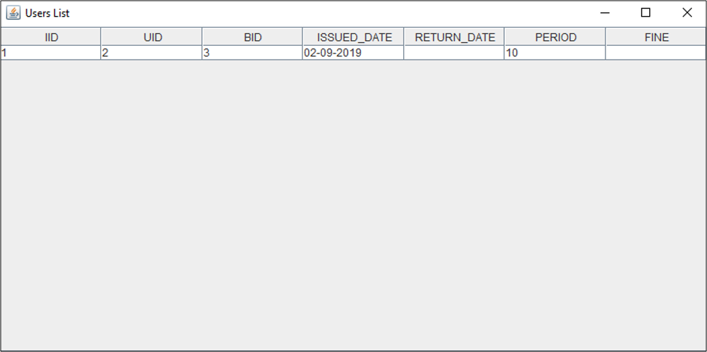

Alright, so, now **if the user logs in to the system**, using the login function, as below:

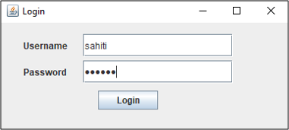

Then the user will see the below User Menu.

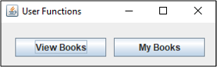

Here, the user can **view all the books** in the database by **using the View Books option** and the **books issued by the user** in the **My Books section** as below:

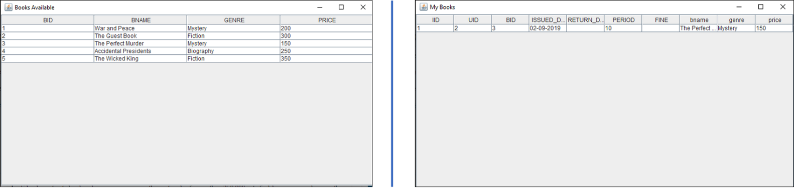

**Return Book**

Once, you click on the Return Book, mention the **Issue ID and the return date** as below. Then click on**Return**.

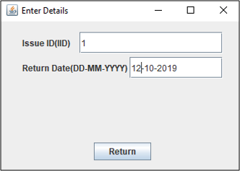

Then, you see a message box displaying the fine.

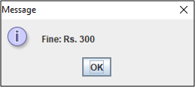

After that, you again see a dialog box, showing the message “**Book Returned**“. Refer below.

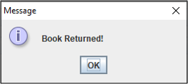

Now, if you click on the **View Issued Books**, you will see the below output:

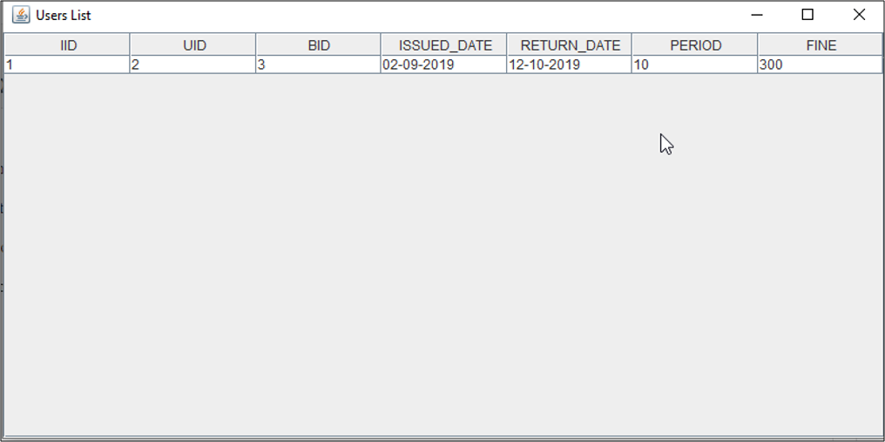

Lastly, if you wish to add a book, you can use the option of Add Book.

**Add Book**

Click on the **Add Book button**, and mention the **book name, genre and price**. Then, click on the **Submit button**. Refer below.

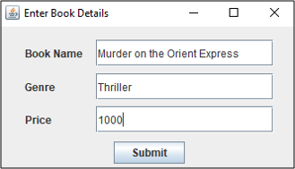

You will see a dialog box displaying the below message:

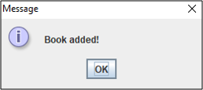

Apart from this, you can also, see the added books in the **View Books** section as below:

